PRAKTEK TUGAS 2
Soal NO 1:
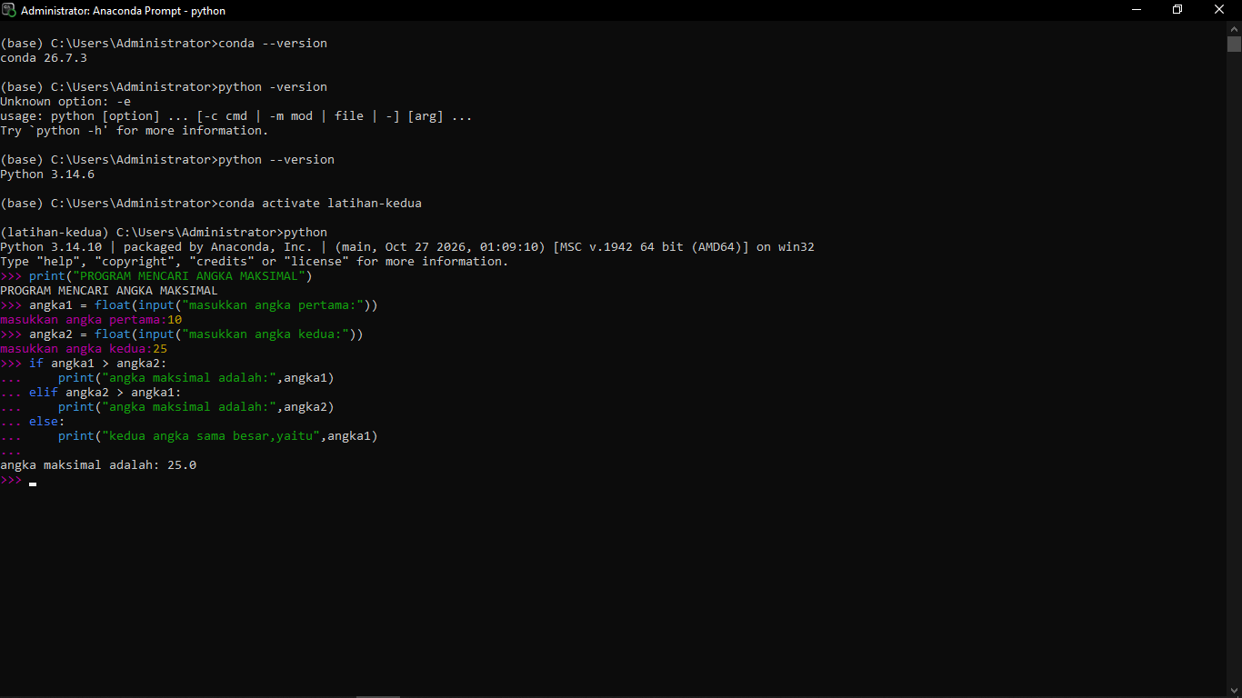

Soal NO 2:


